Recording Online Instruction in Baltimore City Public Schools
Contents
Permission Process 1
Recording Options 3
Option 1: Record Through Zoom 3
Option 2: Record with Your Phone 3

Permission Process
BCPSS interns are allowed to use recordings of Zoom sessions with students for edTPA purposes. Student faces should not be visible in the recording.
Any students who will be recorded need to have a permission form signed by their parent/guardian. Towson University has a recording permission form that has been approved by our legal department as well as BCPSS.
We have digitized this form so that it can be distributed and completed more easily. There is a drop-down menu in the upper right corner so that families can choose the English or Spanish version of the form.
We have one central copy of this form in Qualtrics so that we will have a record of all families’ responses in one place. Please do not make a copy of the form.
- To distribute the form to families, interns should use the email template on the next page, adding the appropriate information where indicated. (Interns should follow their mentor teacher’s instructions about how to send out the message to families and should be sure to CC the mentor teacher on all communication.)
- Interns automatically should receive an email from Qualtrics each time a family completes the form. The edTPA Coordinator will also send out a master list of the responses for interns in each cohort.
- If a family indicates that their child cannot be recorded, or the family does not complete the form, that child should not be included in the recording or have work samples used for university assignments or edTPA. Interns will need to work with their mentor teacher to determine a plan for the students who cannot be recorded.

Dear Families,
I hope you are doing well. I am a teacher intern from Towson University who will be working with [mentor teacher name] this semester. I am excited to be completing my teacher preparation program in your child’s class.
As part of my program, I am required to make digital recordings of lessons that I teach and to collect samples of student work. My university has worked closely with the school district to develop procedures for doing this. Please read the letter at the following link, then complete and sign the brief permission form. (You will be able to indicate whether you give permission or deny permission when you sign.)
Student Release Form (You can also copy and paste the URL in your browser: https://towson.az1.qualtrics.com/jfe/form/SV_0TCVOXCvh1UasYJ)
You will be asked to enter the following information when you complete the form:
School: [provide name for families to copy/paste]
Grade:
Teacher Name: [provide name for families to copy/paste]
TU Teacher Intern Name: [provide name for families to copy/paste]
Please let me know if you have any questions, and thank you for your support!
Sincerely,
[Teacher Intern Name]

Recording Options

Option 1: Record Through Zoom
Your mentor teacher is able to record the Zoom meeting for you using the Zoom cloud recording option. Your mentor will then need to download the file and share it with you.
Your mentor will need to go “My Recordings” in their Zoom account and press the arrow to download one of the files. “Shared screen with speaker view” or “shared screen with gallery view” will work well if those are listed as options.
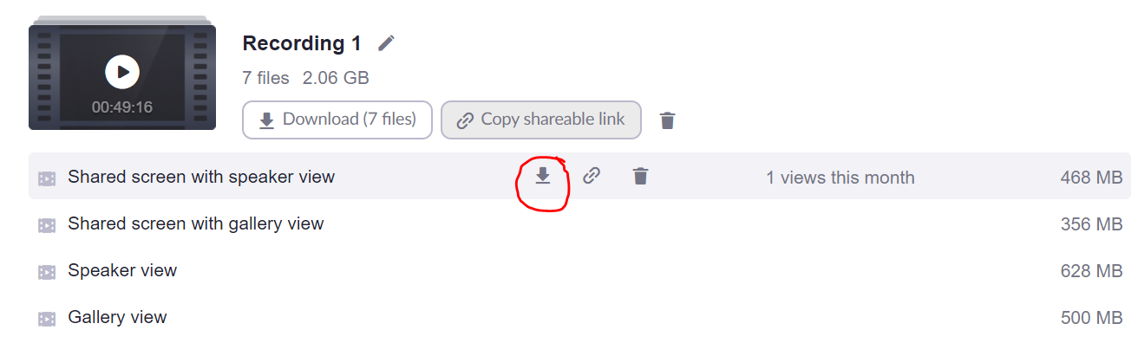
Because this file will be large, your mentor teacher will need to share it via Google Drive or OneDrive. The file will be too large for email.
IMPORTANT: The recording function in Zoom does not record breakout rooms. If you are going to meet with an individual or a small group of students, you will want to meet in the main room, and have everyone else move to breakout rooms.

Option 2: Record with Your Phone
Alternatively, you can use your cell phone camera to record yourself and your computer screen. Remember that you must be visible in your recording! You will want to test this ahead of time to make sure your computer audio is loud enough to be heard in the recording.

