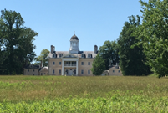
Student Resource – “Amplifying Voices”

Welcome!

Are you ready to explore Maryland’s history?
Which historical issues still have an impact on society today?
How might you make a difference regarding an issue of importance to you?

- First, please explore the Amplifying Voices PowerPoint and your initial exploration of the Hampton National Historic Site. Complete your quickwrite, questions, and reflection.
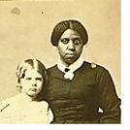

- Then, investigate the historical information available via the Hampton website [https://www.nps.gov/hamp/learn/historyculture/slavery-at-hampton.htm]. Can you answer any of the questions that you have posed? What additional questions do you have?

- Next, select a poet who depicts topics that you would like to explore further. Please complete the TPCASTT analysis regarding two of your chosen poet’s poems.

- Frances Ellen Watkins Harper: Harper is considered the mother of African American journalism; she was a teacher, writer, activist who was born of free African American parents in Baltimore in the mid-1850’s.

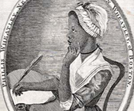
- Jean Toomer: Toomer, the son of a Georgian farmer, was born in the late 1800s. He passed for white and strove for racial unity; however, he was raised in a predominantly black community and criticized for marrying white women.

- Phillis Wheatley was the first published black poet in America; originally from the West Indies, Wheatley was enslaved in New England at the age of 8 and was freed about 15 years later.
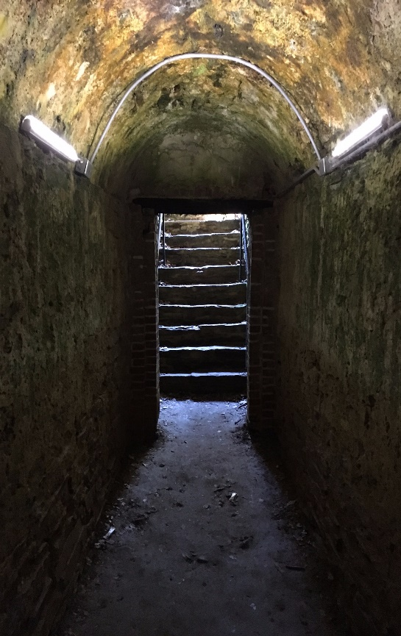
- Finally, complete your predictions of the Improving Inquiry and Inferences PowerPoint. Do you have any additional questions? Could you answer any of the questions with information gleaned at the Hampton website?

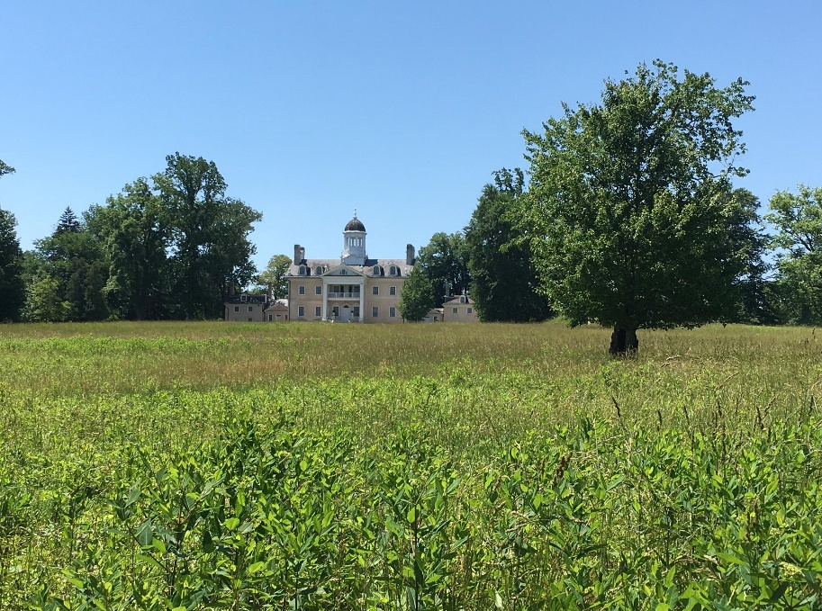

Will you be able to visit the Hampton National Historic Site?

- If so, enjoy! Please bring your questions, a writing implement, and a notebook on which you can jot down fascinating finds. Consider taking pictures, so you have ample details with which to work! When you return, be ready to create your own writings inspired by your experiences.

- If not, please continue on to create your own explorations of issues and themes of historical and current importance.

