Assignment #11 Text Set

Elizabeth Gleitsmann
EDUC 717
May 23, 2017

Assignment #11: Text Set

UNIT CONCEPT WEB

UNIT CONCEPT ORGANIZER
Unit Concept: American Revolution
Grade: 5 Curricular Area: Social Studies
Common Core Goals/Expectations/ Indicators:
(There are not any Common Core State Standards for Social Studies, so I decided to include the appropriate English Language Arts Standards, since students will be need to apply them when reading, speaking or listening, and writing for the appropriate instructional activities and texts.)

Standards for Reading Literature (RL)
CCSS.ELA-LITERACY.RL.5.1
Quote accurately from a text when explaining what the text says explicitly and when drawing inferences from the text.

Standards for Reading Informational Text(RI)
CCSS.ELA-LITERACY.RI.5.3
Explain the relationships or interactions between two or more individuals, events, ideas, or concepts in a historical, scientific, or technical text based on specific information in the text.
CCSS.ELA-LITERACY.RI.5.6
Analyze multiple accounts of the same event or topic, noting important similarities and differences in the point of view they represent.
CCSS.ELA-LITERACY.RI.5.9
Integrate information from several texts on the same topic in order to write or speak about the subject knowledgeably.

Standards for Speaking & Listening(SL)
CCSS.ELA-LITERACY.SL.5.4
Report on a topic or text or present an opinion, sequencing ideas logically and using appropriate facts and relevant, descriptive details to support main ideas or themes; speak clearly at an understandable pace.
CCSS.ELA-LITERACY.SL.5.5
Include multimedia components (e.g., graphics, sound) and visual displays in presentations when appropriate to enhance the development of main ideas or themes.

Standards for Language (L)
CCSS.ELA-LITERACY.L.5.2
Demonstrate command of the conventions of standard English capitalization, punctuation, and spelling when writing.
CCSS.ELA-LITERACY.L.5.3
Use knowledge of language and its conventions when writing, speaking, reading, or listening.

Standards for Writing (W)
CCSS.ELA-LITERACY.W.5.1
Write opinion pieces on topics or texts, supporting a point of view with reasons and information.
Maryland Voluntary State Curriculum Standard: 5.0 History
Maryland Voluntary State Curriculum Goals/Indicators/Objectives:
Topic B. Emergence, Expansion, and Changes in Nations and Empires
2. Analyze the growth and development of colonial America
c. Analyze the different roles and viewpoints of individuals and groups, such as women, men, free and enslaved Africans, and Native Americans during the Revolutionary period.

Topic C. Conflict Between Ideas and Institutions
1. Analyze the causes of the American Revolution
a. Identify and sequence key events between the French and Indian War and the American Revolution.
b. Examine the viewpoints of Patriots and Loyalists regarding British colonial policy after the Seven Years' War.

2. Analyze the effects of the American Revolution
a. Analyze how the revolution altered colonial and national governments
b. Describe individual freedoms that resulted from the formation of an independent nation.

AASL Standards for 21st Century Learners:

Standard 1: Inquire, think critically, and gain knowledge.
1.1.6 Read, view, and listen for information presented in any format (e.g., textual, visual, media, digital) in order to make inferences and gather meaning.
1.2.3 Demonstrate creativity by using multiple resources and formats.
1.2.4 Maintain a critical stance by questioning the validity and accuracy of all information.
1.3.1 Respect copyright/ intellectual property rights of creators and producers.
1.3.3 Follow ethical and legal guidelines in gathering and using information.
1.5.5 Use information technology responsibly.
1.4.3 Monitor gathered information, and assess for gaps or weaknesses.

Standard 2: Draw conclusions, make informed decisions, apply knowledge to new situations, and create new knowledge.
2.1.1 Continue an inquiry based research process by applying critical thinking skills (analysis, synthesis, evaluation, organization) to information and knowledge in order to construct new understandings, draw conclusions, and create new knowledge.
2.1.2 Organize knowledge so that it is useful.
2.1.4 Use technology and other information tools to analyze and organize information
2.2.4 Demonstrate personal productivity by completing products to express learning.
2.3.2 Consider diverse and
global perspectives in
drawing conclusions

Standard 3: Share knowledge and participate ethically and productively as members of our democratic society.
3.1.3 Use writing and speaking skills to communicate new understandings effectively.
3.1.4 Use technology and other information tools to organize and display knowledge and understanding in ways that others can view, use, and assess.
3.1.6 Use information and technology ethically and responsibly.
3.2.3 Demonstrate teamwork by working productively with others
3.3.4 Create products that apply to authentic, real-world contexts.
3.3.7 Respect the principles of intellectual freedom
3.4.2 Assess the quality and effectiveness of the learning product.

Standard 4: Pursue personal and aesthetic growth.
4.1.1. Read, view, and listen for pleasure and personal growth.
4.1.2 Read widely and fluently to make connections with self, the world, and previous reading
4.1.6 Organize personal knowledge in a way that can be called upon easily.
4.1.8 Use creative and artistic formats to express personal learning.
4.2.3 Maintain openness to new ideas by considering divergent opinions, changing opinions or conclusions when evidence supports the change, and seeking information about new ideas encountered through academic or personal experiences.
4.3.2 Recognize that resources are created for a variety of purposes.
4.4.3 Recognize how to focus efforts in personal learning.

TEXT OVERVIEW CHART
Unit: American Revolution
Causes  (Background Information) | Battles | Documents | Different Perspectives: Patriots vs. Loyalists
- BrainPop  (“Causes of the American Revolution”)  - Discovery Education  (“The Beanbody Histories”)  - WorldBook Student  - If You Lived at the Time of the American Revolution  - American Revolution  - The Boston Tea Party  - For Liberty: The Story of the Boston Massacre  - Youtube  (“Schoolhouse Rock”)  - BrainPop  (“American Revolution”)  - Safari Montage  (“Causes of the Revolution”)  - Discovery Education  (“History Kids”) | - Let it Begin Here: Lexington & Concord: First Battles of the American Revolution  - Discovery Education  (“The Revolutionary War Series”)  - Safari Montage  (“The Revolutionary War”)  - WorldBook Student  - “The American Revolution” | - The Declaration of Independence from A to Z  - Youtube  (“Liberty’s Kids”)  - Safari Montage  (“The Revolutionary War”)  - National Archives | - The Midnight Rid of Paul Revere  - Dear America: The Winter of Red Snow  - A True Patriot: The Journal of William Thomas Emerson, A Revolutionary War Patriot  - They Called her Molly Pitcher  - Gingerbread for Liberty  - George vs. George: The American Revolution as Seen from Both Sides  - Liberty or Death  - Benedict Arnold: Battlefield Hero or Selfish Traitor?  - Revolutionary War on Wednesday*  - Johnny Tremain*  - My Brother Sam is Dead*  - Tolliver’s Secret*  - Fighting Ground*  - Remember Valley Forge: Patriots, Tories, and Redcoats Tell Their Stories  - Turning Points: Sons of Liberty  - Give Me Liberty*  - Hope’s Crossing  - African Americans and American Indians Fighting in the Revolutionary War  *Denotes use in reading small groups within the classroom

UNIT INSTRUCTIONAL ACTIVITIES
Instructional Activity for Topic 1: Causes and Other Background Information
Objective: Today we will explain why the colonists wanted independence from the British in order by examining and identifying the causes of the American Revolution.
- The teacher will introduce the unit by having students view the BrainPop Video “American Revolution.”
- Explain that students will work with small groups to create a web either a paper version or Microsoft version using Smart Art in order to identify the causes of the American Revolution.
- The each group will be assigned one of the causes:
Group 1: French and Indian War
Group 2: Sugar Act
Group 3: Townshend Acts
Group 4: Boston Massacre
Group 5: Boston Tea Party/ Tea Act
Group 6: Intolerable Acts
The students will use resources (1-7 and 9-11) to find out more information about each cause, such as: who was involved, what happened, where it happened, when did it happen, why did it happen, and how did it lead to the American Revolution.
- Have one student from each group volunteer to share their new knowledge out loud with the rest of the class.
- To end the lesson, show students the Youtube video “The Short Heard Round the World.”
Instructional Activity for Topic 2: Battles of the American Revolution
Objective: Today we will identify and sequence key events between the French and Indian War and the American Revolution by composing a timeline with the significant events.
- Remind students of the Schoolhouse Rock video they viewed during topic #1. Explain that the first shot heard around the world occurred at Lexington and Concord, which is one of the battles of the American Revolution.
- Students will use information from Resources 1- 5 to complete a timeline in a small group. Students will either use the paper version, timeline template on Wixie, or the interactive PowerPoint (teacher created) in order to create the timeline.
Students will have to list:
-Name of Battle
-Map of Location
-Date of Battle
-Leaders of Each Army (If able to locate)
-Which side won
-Important Facts/ Significance
*(Student Accommodations: Have cut and paste activity with already selected battles and information for students to complete)
- Have each group volunteer to share about one different battle out loud with the rest of the class.
- Extension: Show an episode of Liberty’s Kids related to one of the battles.

Instructional Activity for Topic 3: Documents
Objective: Today we will be able to interpret the Declaration of Independence and other documents of the American Revolution in order to determine the purpose of the document.
- Have students share the causes of the American Revolution.
- Show an episode of Liberty’s Kids about the Intolerable Acts.
- Explain that there were many effects as a result of the American Revolution, some of which were important documents.
- The teacher will model how to complete the graphic organizer about the Intolerable Acts.
- Students will use information from the resources to complete a graphic organizer. The students will examine the Declaration of Independence and Treaty of Paris to learn about: who made it, when was it made, and what the purpose of the document was.
- Students will use their notes to complete a cartoon or poster about one of the documents. Their completed assessments will be displayed in the classroom.

Instructional Activity for Topic 4: Different Perspectives: Patriots vs. Loyalists
Objective: Today we will examine the viewpoints of Patriots and Loyalists regarding British colonial policy in order to compare and contrast their different perspectives.
- The teacher introduce this topic by stating that there are two sides to every war like there are two sides to every story.
- The teacher will explain that in the American Revolution the two sides were the Patriots with George Washington and then the British/ Loyalists with King George III.
- The teacher will read selected sections of George vs, George: The American Revolution as seen from Both Sides. (Pages 8-11, 12- 13, 14-15, 18-22) As the teacher reads, the students will complete a Venn Diagram comparing and contrasting King George vs. George Washington.
- The teacher will present different scenarios from each side. The students will then pick the choice that best represents what they would have done if they were living during the time of the American Revolution. (This can either be done on paper with tally marks or by having students get up and walk to sides of the room.) At the end, students will learn if they would have been a Loyalist or Patriot.
- Extension: Students will explore the other curated resources containing the other perspectives of genders and cultures by participating in a gallery walk. Students will select one of the historical figures they are interested in and use the resources for the topic or WorldBookStudent to learn more about the historical figure. Then students will create a trading card using Wixie or PowerPoint. They must include: the historical figure’s name, the side he or she fought on, and his or her contribution to the war.
Reading Small Groups
During the four topics and completion of the assessment, the class can be broken down into different reading groups either by reading level or interest in the texts. The texts are Revolutionary War on Wednesday (significantly below grade level), Johnny Tremain (above grade level), My Brother Sam is Dead (on grade level), Tolliver’s Secret (above grade level), Fighting Ground (on grade level), Give Me Liberty (below grade level). Students will participate in discussion groups/literature circles to discuss the books. Students will use reading skills and strategies, such as making text connections, predicting, and inferring as they read independently. They will complete activities, such as completing story maps and responding to reading response journal prompts. These texts will also be displayed and gathered with the rest of the resources so other students not in that assigned reading group may read them as well.

END OF UNIT ACTIVITY/ ASSESSMENT
Students will create a colonial one page newspaper from the perspective of either a Patriot or Loyalist. To create the newspaper they will use one of the following: the newsletter template on Wixie, DiscoveryEducation Boardbuilder, paper, Microsoft Publisher, or Microsoft Word template. I will review with students how to use DiscoveryEducation Boardbuilder and how to find newsletter templates on Microsoft Word. They will use some of the information they gathered throughout the American Revolution unit to create the newspaper. The students will select one of the following dates for their newspaper:
-December 16, 1773 (Boston Tea Party, Boston Massacre, and Acts)
-April 19, 1775 (Battle of Lexington and Paul Revere’s Ride)
-July 4, 1776 (Declaration of Independence)
-October 1777 (Battle of Saratoga- Turning Point of the American Revolution)
-Winter of 1777 (Valley Forge)
-September 3, 1783 (Battle of Yorktown from 1781 and Treaty of Paris)
Their newspaper should contain the following elements:
-Creative newspaper name in larger print
-Student name
-Told from one perspective of the sides of the American Revolution (May include advertisement wanting you to join the revolution for that side!)
-Mentions at least two causes of the American Revolution
-Mentions one of the documents in the American Revolution (depending on time period)
-Who wrote it, When was it written, and what is the purpose
-Mentions at least two important events from that date it is written from (Includes information to answer the 5W questions)

As students work, they will have a checklist to make sure they have all of the necessary components for their newspaper. (The checklist has been included below.) The teacher will go over the checklist/rubric and then evaluate the model using the rubric. The teacher will model how to edit the model of the newspaper.

EXAMPLE OF EXEMPLAR STUDENT PRODUCT
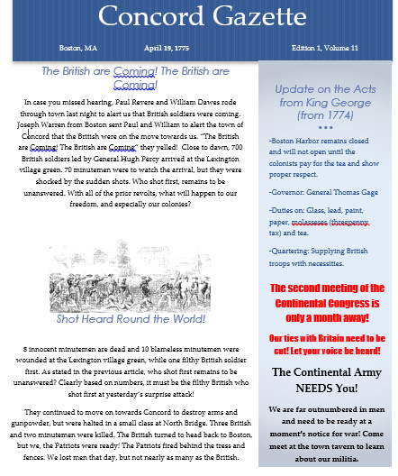

ASSESSMENT FOR END OF UNIT ACTIVITY
Rubric for Assessment
Student Name: _______________________ Homeroom: _________________________
Category | 4 | 3 | 2 | 1
Causes of the American Revolution | The summary accurately describes at least two causes of the event: what occurred in the event, and the effect. | The summary describes at least two causes of the event: what occurred in the event, and the effect, but may be lacking information. | The summary describes at least one cause of the event: what occurred in the event, and the effect, but may be lacking information. | The summary is incorrect, lacking significant information of the event: what occurred in the event, and the effect.
Documents of the American Revolution | The summary accurately mentions one of the documents with information about: who made it, when was it made, and what the purpose of the document. | The summary accurately mentions one of the documents with information about: who made it, when was it made, and what the purpose of the document, but may be lacking information. | The summary accurately mentions one of the documents with information about: who made it, when was it made, and what the purpose of the document, but lacks several pieces of the necessary information. | There is no summary or information about one of the articles of the American Revolution.
Battles/Events of the American Revolution | The summary contains accurate answers to the 5 W (who, what, when, where, why) questions, and which side won for two battles or events. | The summary contains answers to the 5 W (who, what, when, where, why) questions, and which side won for two battles or events, but may be lacking information. | The summary contains accurate answers to the 5 W (who, what, when, where, why) questions, and which side won for one battle or event. | The summary contains incorrect answers to the 5 W (who, what, when, where, why) questions, and which side won for one or less battles.
Perspective/ Voice | The student has written entirely from the perspective of one of the sides of the American Revolution. | The student has written mostly from the perspective of one of the sides of the American Revolution. | The student writes equally from both perspectives of one of the sides of the American Revolution. | It is too difficult to see what side of the American Revolution, which the student is writing for or may be off task.
Organization/Neatness | The newspaper is neat and creative. The information is very easy to read and is engaging. | The newspaper is mostly neat and creative. The information is very easy to read and is engaging | The newspaper is neat and creative. The information is difficult to read. | The newspaper is neither neat nor creative. The information is illegible.
Spelling and Grammar | Student had 0-1 spelling or grammar mistake. | Student had 2-3 spelling or grammar mistakes. | Student had 4-5 spelling or grammar mistakes. | Student had 6 or more spelling or grammar mistakes.

Student Project Checklist
______________________________’s American Revolution Project Checklist

Directions: Place a check or x next to each element as you work on your newspaper to ensure that all elements of the rubric are included.
My project is in a newspaper format or layout.
The title of my newspaper is a larger size then the rest of the text.
My name is on my newspaper.
The date is relevant to an important time during the Revolution
I wrote from one perspective mainly. My perspective was as a _______________________________________________.
I mentioned two causes of the American Revolution. The two causes are: _______________________________________________ and _________________________________________________
I mentioned one document of the American Revolution. The document I mentioned was __________________________________________.
I included information on two important events or battles of the American Revolution. The two events or battles are _____________________________________________________ and ________________________________________________________.
I have edited my newspaper for spelling and grammar.
My newspaper is neat and organized. I have included at least one image or map to make it engaging.

UNIT BIBLIOGRAPHY
Topic #1 Causes of American Revolution and Other Background Information
Resource #1
BrainPop (Causes of the American Revolution)
Bibliographic Entry: | BrainPop. (2017). Causes of the American Revolution. Retrieved from https://www.brainpop.com/socialstudies/ushistory/causesoftheamericanrevolution/
Dewey Decimal Notation:  N/A | Genre:  N/A | Ability:  Grade 3 and up
How this resource supports the topic: | This resource tells about the major causes of the American Revolutionary War. This resource will help students understand the tension between Britain and the original 13 colonies, why the colonists boycotted British goods, the various taxes, the Boston Tea Party, and the role of the Sons and Daughters of Liberty. This resource could be used as an engaging introductory video for the instructional activities, or it could be used as a resource for students to independently use for research during the instructional activity. This resource would help students who learn best by auditory or visual learning style when using it as an independent resource.

Resource #2
Discovery Education (“The Beanbody Histories: The American Revolution: Part 1: Causes”)
Bibliographic Entry: | Colman Communications. (2013). The Beanbody histories: The American Revolution: Part 1: Causes.[Video Segment]. Retrieved from https://bcps.discoveryeducation.com/player/view/assetGuid/ebb23e56-0286-46aa-b81d-4f90c7e4cb22
Dewey Decimal Notation:  N/A | Genre:  N/A | Ability:  Grades 3-8
How this resource supports the topic: | This resource tells of a few events that led to the American Revolution. This resource is presented in the format of an animated cartoon. This engaging resource will help students to understand the reason why Britain began to tax the colonies, and then how they began to protest. This resource could be used as an engaging introductory video for the instructional activities, or it could be used as a resource for students to independently use during the instructional activity. This resource would help students who learn best by auditory or visual learning style when using it as an independent resource. Students can easily access it through the Baltimore County Public Schools’ databases.

Resource #3
World Book Student (“American Revolution”)
Bibliographic Entry: | Sheidley, N. (2017). American Revolution. World Book Student. Retrieved from http://www.worldbookonline.com/student/article?id=ar466820
Dewey Decimal Notation:  N/A | Genre:  N/A | Ability:  Grades 3-8
How this resource supports the topic: | This resource tells in extensive detail about the American Revolution. This resource contains the following contents: background and causes of the revolution, the beginning of the war, the progress of the war, the war in different regions, the end of the war, and the results of the revolution. It is a great resource for this unit since it contains specific information about the causes of the American Revolution, documents, battles, and the roles of the Patriots and Loyalists. It contains images, videos, maps of the battles, a timeline of the important dates, and a list of major battles. There is a list of related information for: background and causes, American military leaders, American civilian leaders, and British leaders, battles, and other related articles. This resource could be used independently by students throughout the unit, especially for the causes of the American Revolution. WorldBookStudent also has many accommodations to assist students with special needs, such as text-to-speech for students with auditory needs or the translate option for students who are English-Language-Learners. Students can easily access it through the Baltimore County Public Schools’ databases.

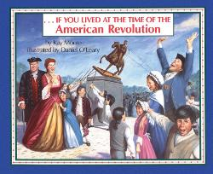 | Resource #4  If You Lived at the Time of the American Revolution
Bibliographic Entry: | Moore, K. & O’Leary, D. (2006). If you lived at the time of the American Revolution. New York, NY: Scholastic.
Dewey Decimal Notation:  973.3 MOO | Genre:  Nonfiction | Ability:  Interest Level: 3-6  Reading Level: 6.3
How this resource supports the topic: | This book is about what life was like in Colonial America. This resource will help students better understand the causes of the Revolutionary War, an introduction to the Loyalists and the Patriots, and how things changed once the conflict began. This resource could be used independently by students throughout the unit. This resource could be gathered in a central location in the classroom with other texts related to the American Revolution unit.

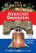 | Resource #5  American Revolution
Bibliographic Entry: | Osborne, M. (2017). American Revolution. New York City, NY: A Stepping Stone Book, Random House.
Dewey Decimal Notation:  973.3 OSB | Genre:  Nonfiction | Ability:  Interest Level: 3-6  Reading Level: 4.5
How this resource supports the topic: | This book is a companion to the Revolutionary War on Wednesday by Mary Pope Osborne. This resource will help students better understand colonial life, the Declaration of Independence, the causes of the war, major events of the American Revolution, and other related information. Text features, such as photographs of primary sources, support the information. This resource could be used independently by students throughout the unit. This resource could be gathered in a central location in the classroom with other texts related to the American Revolution unit.

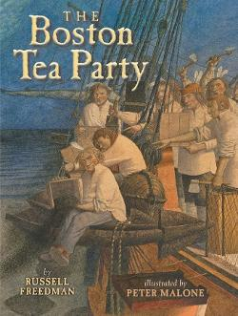 | Resource #6  The Boston Tea Party
Bibliographic Entry: | Freedman, R. & Malone, P. (2012). The Boston tea party. New York City, NY: Holiday House.
Dewey Decimal Notation:  973.3 FRE | Genre:  Nonfiction | Ability:  Interest Level: 3-6  Reading Level: 6.8
How this resource supports the topic: | This book introduces readers to the Boston Tea Party and its impact on American history through the story behind the facts. This resource will help students understand the Boston Tea Party better through the engaging story, afterword of the connection to the American Revolution, bibliography, and a timeline. This resource could be used independently by students throughout the unit. This resource could be collected and displayed in a central location in the classroom with other texts related to the American Revolution unit. Since there are 39 pages, this text could also be used as a read aloud by the teacher.

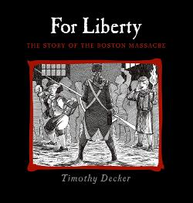 | Resource #7  For Liberty : The Story of the Boston Massacre
Bibliographic Entry: | Decker, T. (2009). For liberty: The story of the Boston Massacre. Honesdale, PA: Calkins Creek.
Dewey Decimal Notation:  973.3 DEC | Genre:  Nonfiction | Ability:  Interest Level: 3-6  Reading Level: 5.4
How this resource supports the topic: | This book is about the Boston Massacre in the form of a nonfiction picture storybook. This resource will help students to better understand the event of the Boston Massacre with the confrontation between Boston’s colonists and the soldiers, followed by the challenges of British rule. This resource could be used independently by students throughout the unit. This resource could be collected and displayed in a central location in the classroom with other texts related to the American Revolution unit. Since there are 37 pages, this text could also be used as a read aloud by the teacher.

Resource #8
“Schoolhouse Rock!: America-The Short Heard ‘Round the World”
Bibliographic Entry: | Disney Educational Prodructions. (2012). Schoolhouse rock!: America-The shot heard ‘round the world. Retrieved from https://www.youtube.com/watch?v=rZMmPWTwTHc
Dewey Decimal Notation:  N/A | Genre:  N/A | Ability:  Grades 3 and up
How this resource supports the topic: | This video is from the popular series, “Schoolhouse Rock.” This video is a classic educational animated song about the American Revolution. The video begins with Paul Revere’s famous ride followed by the shot at Lexington that was heard around the world before going through the rest of the events until the end of the war in Yorktown. This resource will help students to remember some of the events or the brief important highlights of the American Revolution through the catchy song and animated cartoons. This resource could be used as an engaging introductory video for the instructional activities. The teacher would have to play this in the front of the classroom, since students do not have access to Youtube due to the web filter.

Resource #9
BrainPop (American Revolution)
Bibliographic Entry: | BrainPop. (2017). American Revolution. Retrieved from https://www.brainpop.com/socialstudies/ushistory/americanrevolution/
Dewey Decimal Notation:  N/A | Genre:  N/A | Ability:  Grade 3 and up
How this resource supports the topic: | This resource is about the basics of the American Revolutionary War. This resource will help students learn about who and what helped begin the Revolution, the major points during the war, the turning point victory, how the war ended and the important role that George Washington played. This resource could be used as an engaging introductory video for the instructional activities. The students could viewed independently by students throughout the unit. This resource would help students who learn best by auditory or visual learning style when using it as an independent resource.

Resource #10
Safari Montage (Causes of the Revolution 1765-1774)

Bibliographic Entry: | Schlessinger Media. (2003). Causes of the revolution (1765-1774). [Full Video]. Retrieved from https://safariwan.bcps.org/?a=1701&d=00386AA
Dewey Decimal Notation:  N/A | Genre:  N/A | Ability:  Grades 5 to 9
How this resource supports the topic: | This video is about the causes of the American Revolution. The video is broken into nine chapters which contains an introduction, the causes of the Revolution, England’s responses, and a conclusion. This resource will help students better understand the events, Acts, and protests from patriots that helped to cause the American Revolution. The students could viewed independently by students throughout the unit. This resource could be used to help students who learn best by auditory or visual learning style when using it as an independent resource.

Resource #11
Discovery Education (“History Kids: Causes of the Revolutionary War”)
Bibliographic Entry: | Wonderscape. (2017). History kids: Causes of the revolutionary war. [Full Video].Retrieved from https://bcps.discoveryeducation.com/player/view/assetGuid/6033934d-d1a3-428f-8d66-db71a01882c9
Dewey Decimal Notation:  N/A | Genre:  N/A | Ability:  Grades 3-8
How this resource supports the topic: | This resource is about the causes of the revolutionary war. This resource will help students learn some of the key laws, people, and events that lead to the American Revolution. The video is broken into four segments which contain the causes of the Revolution, such as The French and Indian War, the Stamp Act, the Boston Tea Party, the Intolerable Acts, and the Continental Congress. The students could viewed independently by students throughout the unit. This resource could be used to help students who learn best by auditory or visual learning style when using it as an independent resource.

Topic #2: Battles of American Revolution
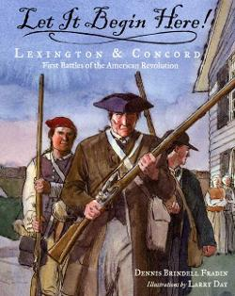 | Resource #1  Let it begin here! : Lexington & Concord : First Battles of the American Revolution
Bibliographic Entry: | Fradin, D. & Day, L. (2005). Let it begin here!: Lexington & Concord:First battles of the American Revolution. New York City, NY: Walker Publishing Company.
Dewey Decimal Notation:  973.3 FRA | Genre:  Nonfiction | Ability:  Interest Level: 3-6  Reading Level: 5.8
How this resource supports the topic: | This book is about the battles of Lexington and Concord. This resource will help students better understand the events of April 18 and 18, 1775 at Lexington and Concord through the use of headings containing the date and time. The book also contains a map of the Boston area, and a list of important people that played a role in the battle. This resource could be used independently by students throughout the unit. This resource could be collected and displayed in a central location in the classroom with other texts related to the American Revolution unit. Since there are 32 pages, this text could also be used as a read aloud by the teacher.

Resource #2
Discovery Education (“The Revolutionary War Series: The War and a New Nation”)
Bibliographic Entry: | 100% Educational Videos, 2003. The Revolutionary War series: The war and a new nation. [Full Video]. Retrieved from https://bcps.discoveryeducation.com/player/view/assetGuid/349ba654-469b-4ee6-897a-796fe47c0c4e
Dewey Decimal Notation:  N/A | Genre:  N/A | Ability:  Grades 3 and up
How this resource supports the topic: | This resource is about the events surrounding the Revolutionary War. This resource will help students learn about the battles, such the early battles, battles on the water with John Paul Jones, and then the Battle of Yorktown. The video segment on the Declaration of Independence could also be used for the instructional activities about the documents of the American Revolution. This resource could be used as an engaging introductory video for the instructional activities about battles. This resource would help students who learn best by auditory or visual learning style when using it as an independent resource.

Resource #3
Safari Montage (“The Revolutionary War, 1776-1783”)

Bibliographic Entry: | Schlessinger Media. (2004). The Revolutionary War (1776-1783) [Full Video]. Retrieved from https://safariwan.bcps.org/?a=1703&d=02083AA
Dewey Decimal Notation:  N/A | Genre:  N/A | Ability:  Grades 5 to 9
How this resource supports the topic: | This resource is about the battles of the American Revolution. The major battles are broken down into individual chapters by chronological order. This resource will help students understand the battles, participants and leaders, and some of the documents, such as the Treaty of Paris that helped to impact the American Revolution. This resource could be used as an engaging introductory video for the instructional activities about battles. This resource would help students who learn best by auditory or visual learning style when using it as an independent resource.

Resource #4
“American Revolution”
Bibliographic Entry: | Sheidley, N. (2017). American Revolution. World Book Student. Retrieved from http://www.worldbookonline.com/student/article?id=ar466820
Dewey Decimal Notation:  N/A | Genre:  N/A | Ability:  Grades 3-8
How this resource supports the topic: | This resource tells in extensive detail about the American Revolution. This resource contains the following contents: background and causes of the revolution, the beginning of the war, the progress of the war, the war in different regions, the end of the war, and the results of the revolution. It is a great resource for this unit, particularly this topic, since it contains specific information about the battles, including maps and a timeline. There is a list of related information for: American military leaders, American civilian leaders, and British leaders, and battles. This resource could be used independently by students throughout the unit. WorldBookStudent also has many accommodations to assist students with special needs, such as text-to-speech for students with auditory needs or the translate option for students who are English-Language-Learners. Students can easily access it through the Baltimore County Public Schools’ databases.

Resource #5
“The American Revolution”
Bibliographic Entry: | Logan, J. (2001). The American Revolution. Retrieved from  http://theamericanrevolution.org/battles.aspx
Dewey Decimal Notation:  N/A | Genre:  N/A | Ability:  Grades 4 and up
How this resource supports the topic: | This resource tells in extensive detail about the American Revolution. This resource contains the battles organized in chronological order. When the user clicks on the name of a battle, more information, such as commanders, causalities appear. It is a great resource for this unit since it contains specific detailed information about each battle. This resource could be used independently by students throughout the unit.

Topic#3: Documents of American Revolution
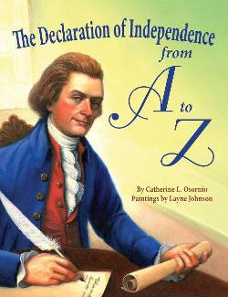 | Resource #1  The Declaration of Independence from A to Z
Bibliographic Entry: | Osornio, C. & Johnson, L (2010). The Declaration of Independence from a to z. Gretna, LA: Pelican Publishing Company.
Dewey Decimal Notation:  973.3 OSO | Genre:  Nonfiction | Ability:  Interest Level: 3-6  Reading Level: 6.0
How this resource supports the topic: | This book is an alphabetical overview of the Declaration of Independence, one of the important documents of the American Revolution. The events selected for a letter are in chronological order from the Boston Tea Party to the Declaration of Independence and then a few of their following consequences. This resource will serve as a supplemental resource to the original Declaration of Independence. This resource could be used independently by students throughout the unit. This resource could be collected and displayed in a central location in the classroom with other texts related to the American Revolution unit. Since there are 32 pages, this text could also be used as a read aloud by the teacher.

Resource #2
Youtube “Liberty’s Kids 102- Intolerable Acts”
Bibliographic Entry: | Liberty’s Kids. (2016). Intolerable acts. Retrieved from: https://www.youtube.com/watch?v=SlRnkQtd2g8
Dewey Decimal Notation:  N/A | Genre:  N/A | Ability:  Grades 3 and up
How this resource supports the topic: | Liberty’s Kids is a video series about the American Revolution. Two teenage reporters cover the events of the Revolutionary War for Ben Franklin’s newspaper. James, an American colonist gives the rebels’ point of view, while Sarah, a young English woman, gives the British viewpoint. Each episode covers different important topics of the American Revolution This resource will help students to relate to and visualize the people, the events, the documents, and the different perspectives of both sides of the American Revolution. This particular resource will help student learn about the Intolerable Acts that were put into place. This resource could be used as an engaging introductory or extension video for the instructional activities about battles. This resource would help students who learn best by auditory or visual learning style when using it as an independent resource. The teacher would have to play this in the front of the classroom, since students do not have access to Youtube due to the web filter.

Resource #3
Safari Montage (“The Revolutionary War, 1776-1783”)

Bibliographic Entry: | Schlessinger Media. (2004). The Revolutionary War (1776-1783) [Full Video]. Retrieved from https://safariwan.bcps.org/?a=1703&d=02083AA
Dewey Decimal Notation:  N/A | Genre:  N/A | Ability:  Grades 5 to 9
How this resource supports the topic: | This resource is about the battles and documents of the American Revolution. This resource will help students understand the participants and leaders, and some of the documents, such as the Treaty of Paris that helped to impact the American Revolution. This resource could be used as an engaging introductory video for the instructional activities about documents. This resource could also be used by students to independently research about the documents. This resource would help students who learn best by auditory or visual learning style when using it as an independent resource.

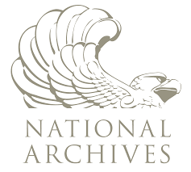 | Resource #4  National Archives (“Declaration of Independence”)
Bibliographic Entry: | National Archives. (2004). Declaration of Independence. Retrieved from https://www.archives.gov/founding-docs/declaration-transcript
Dewey Decimal Notation:  N/A | Genre:  N/A | Ability:  Grades 5 and up
How this resource supports the topic: | This resource contains the actual document of the Declaration of Independence, as well as a transcript that students can read. This resource will help students understand and see the actual document. This resource will be used by students to independently research about the documents, especially the Declaration of Independence. Students can also access the Treaty of Paris through this resource.

Topic#4 Different Perspectives of American Revolution
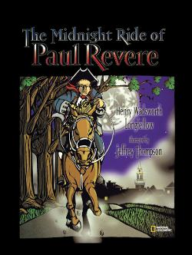 | Resource #1  The Midnight Ride of Paul Revere  (Patriot)
Bibliographic Entry: | Longfellow, H.W. & Thompson, J. (2002). The Midnight ride of Paul Revere. Margate, FL: National Geographic Society.
Dewey Decimal Notation:  811 | Genre:  Poetry/ Picture book | Ability:  Interest Level: 3-6  Reading Level: 6.0
How this resource supports the topic: | This picture book tells Henry Wadswoth Longfellow’s famous poem of Paul Revere’s ride in collaboration with Jeffrey Thompson’s excellent detailed illustrations. This resource will help students learn of one of the most famous Patriot’s ride to warn the colonists that “The British are coming.” This resource could be used independently by students throughout the unit. This resource could be collected and displayed in a central location in the classroom with other texts related to the American Revolution unit. Since there are 32 pages, this text could also be used as a read aloud by the teacher.

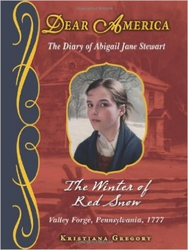 | Resource #2  Dear America: The Winter of Red Snow  (Patriot)
Bibliographic Entry: | Gregory, K. (2010). Dear America: The winter of red snow: The diary of Abigail Jane Stewart. New York, NY: Scholastic.
Dewey Decimal Notation:  F GRE | Genre:  Historical Fiction | Ability:  Interest Level: 5-8  Reading Level: 5.3
How this resource supports the topic: | This book tells the tale of Valley Forge, Pennsylvania in 1777 from eleven-year-old Abigail Stewart’s perspective. She uses her journal to describe her day-to-day life in Valley Forge as General George Washington prepares the Continental soldiers to fight the British. While this text is fictionalized, students, especially girls, will be able to relate to the main character and perhaps learn what it was like during the winter of 1777 in Valley Forge, Pennsylvania. This text could be read independently by students throughout the unit. This text would not be used for research, but instead as self-selected reading. This supplemental resource could be collected and displayed in a central location in the classroom with other texts related to the American Revolution unit. Cannons at Dawn: The Second Diary of Abigail Jane Stewart, the sequel to The Winter of Red Snow would also be a great supplemental resource.

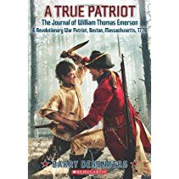 | Resource #3  A True Patriot: The Journal of William Thomas Emerson, A Revolutionary War Patriot  (Patriot)
Bibliographic Entry: | Denenberg, B. (2012). A True patriot: The journal of William Thomas Emerson, a Revolutionary War patriot. New York, NY: Scholastic.
Dewey Decimal Notation:  F DEN | Genre:  Historical Fiction | Ability:  Interest Level: 5-8  Reading Level: 5.6
How this resource supports the topic: | This book tells the experience of twelve-year-old William in pre-Revolutionary War Boston as he joins the Patriots to oppose British rule. While this text is fictionalized, students, especially boys, will be able to relate to the main character and perhaps learn what it is like to be a Patriot in the American Revolution. This text could be read independently as self-selected reading by students throughout the unit. This text would not be used for research, but instead as self-selected reading. This supplemental resource could be collected and displayed in a central location in the classroom with other texts related to the American Revolution unit.

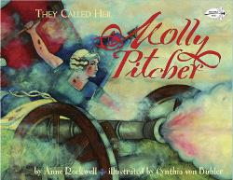 | Resource #4  They Called her Molly Pitcher  (Patriot)
Bibliographic Entry: | Rockwell, A. & Buhler, C. (2006). They called her Molly Pitcher. Decorah, IA: Dragonfly Books.
Dewey Decimal Notation:  973.3 ROC | Genre:  Nonfiction | Ability:  Interest Level: K-3  Reading Level: 5.4
How this resource supports the topic: | This book tells the story of Molly (Hays) Pitcher, a woman who accompanied her husband to join the Continental Arm at Valley Forge in 1777. After her husband is injured, General Washington makes Molly a sergeant for her acts of courage at the Battle of Monmouth. This resource will help students understand that it was not just men who fought in the war, but also that women played a significant role. It will also give the perspective of a Patriot. This text could be read independently as self-selected reading by students throughout the unit This supplemental resource could be collected and displayed in a central location in the classroom with other texts related to the American Revolution unit. Since there are 33 pages, this text could also be used as a read aloud by the teacher.

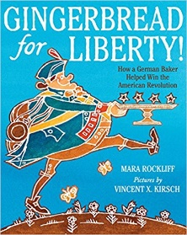 | Resource #5  Gingerbread for Liberty!: How a German Baker Helped Win the American Revolution  (Patriot)
Bibliographic Entry: | Rockliff, M. & Kirsch, V. (2015) Gingerbread for liberty!: How a German baker helped win the American Revolution. Boston, MA: Houghton Mifflin Harcourt.
Dewey Decimal Notation:  973.3 ROC | Genre:  Nonfiction/ Picture Book | Ability:  Interest Level: K-3  Reading Level: 3.5
How this resource supports the topic: | This book is about Christopher Ludwick, a German-born American patriot. As the Revolution began, Christopher was determined to help General George Washington and his hungry troops through the gift of gingerbread. This resource will help students to understand the role of other Patriots besides fighting in the army. It will also give the perspective of a Patriot, especially a former immigrant. This text could be read independently as self-selected reading by students throughout the unit. This text would also be great for students who are reading below grade level or are reluctant readers. This supplemental resource could be collected and displayed in a central location in the classroom with other texts related to the American Revolution unit. Since this is a picture book, this text could also be used as a read aloud by the teacher.

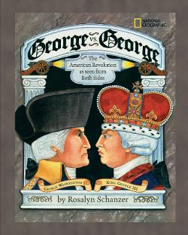 | Resource #6  George vs. George; the American Revolution As Seen from Both Sides  (Patriot and Loyalist)
Bibliographic Entry: | Schanzer, R. (2004). George vs. George: The American Revolution as seen from both sides. Margate, FL: National Geographic Society.
Dewey Decimal Notation:  973.3 SCH | Genre:  Nonfiction | Ability:  Interest Level: 3-6  Reading Level: 7.5
How this resource supports the topic: | This book brings to life both sides of the American Revolution from the perspectives of General George Washngton and King George III. This resource will help students see that there are two sides to every story, especially the American Revolution. It will also give the perspectives of a Patriot George Washington compared to the perspective of King George III (Loyalist). This text could be read independently by students throughout the unit. This supplemental resource could be collected and displayed in a central location in the classroom with other texts related to the American Revolution unit. Since this is a picture book with 60 pages, this text could also be used as a read aloud by the teacher, especially in a lesson about the different perspectives.

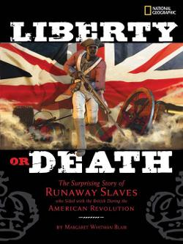 | Resource #7  Liberty or Death: The Suprising Story of Runaway Slaves who Sided with the British during the American Revolution  (Loyalist)
Bibliographic Entry: | Blair, M. (2010). Liberty or death: The surprising story of runaway slaves who sided with the British during the American Revolution. Margate, FL: National Geographic.
Dewey Decimal Notation:  973.3 BLA | Genre:  Nonfiction | Ability:  Interest Level: 5-8  Reading Level: 8.5
How this resource supports the topic: | This book is told from the perspective of African American slaves who fought for the British Royal Army in exchange for freedom. Many were injured or killed, but those that were successful in the war, emigrated to Canada and then West Africa. This resource will help students learn the perspective of a minority, particularly African American slaves that were on the side of the Loyalists. This text could be read independently by students throughout the unit. This supplemental resource could be collected and displayed in a central location in the classroom with other texts related to the American Revolution unit. Since this is a picture book with 64 pages, this text could also be used as a read aloud by the teacher.

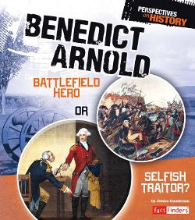 | Resource #8  Benedict Arnold: Battlefield Hero or Selfish Traitor?  (Patriot/Traitor)
Bibliographic Entry: | Gunderson, J. (2014). Benedict Arnold: Battlefield hero or selfish traitor?. Mankato, MN: Capstone Press.
Dewey Decimal Notation:  973.382 GUN | Genre:  Nonfiction | Ability:  Interest Level: 5-8  Reading Level: 5.8
How this resource supports the topic: | This book tells about Benedict Arnold’s life as he fights for the Patriots during the American Revolution before betraying the cause. This resource will help students to learn about a famous Patriot turned traitor. This text could be read independently by students throughout the unit. This supplemental resource could be collected and displayed in a central location in the classroom with other texts related to the American Revolution unit. Since this is a picture book with 32 pages, this text could also be used as a read aloud by the teacher. After reading or listening to this text, students could debate whether Benedict Arnold was indeed a hero or traitor.

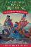 | Resource #9  Revolutionary War on Wednesday  (Patriot)
Bibliographic Entry: | Osborne, M. (2017). Revolutionary War on Wednesday. New York City, NY: A Stepping Stone Book, Random House.
Dewey Decimal Notation:  F OSB | Genre:  Historical Fiction | Ability Level:  Interest Level: K-3  Reading Level: 3.5
How this resource supports the topic: | This book tells the fictional time-travel tale of Jack and Annie who use their magic tree house to travel back to the time of the American Revolution. Jack and Annie help General George Washington as he crosses the Delaware River. This resource will help students to imagine an important moment during the American Revolution as General Washington crosses the river. Since this text is fictionalized, it would not be used for research, but instead as self-selected independent reading. This text would also be great for students who are reading significantly below grade level or are reluctant readers. This supplemental resource could be collected and displayed in a central location in the classroom with other texts related to the American Revolution unit. Teachers could integrate the American Revolution theme into reading and use this text for small groups.

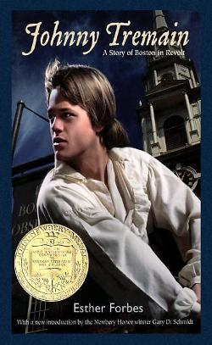 | Resource #10  Johnny Tremain  (Patriot)
Bibliographic Entry: | Forbes, E & Ward, L. (2017). Johnny Tremain. . Boston, MA: Graphia.
Dewey Decimal Notation:  F FOR | Genre:  Historical Fiction | Ability Level:  Interest Level: 5-8  Reading Level: 5.9
How this resource supports the topic: | This book is about Johnny, a silversmith’s apprentice in Boston, who becomes a messenger for the Sons of Liberty prior to the start of the American Revolution. This resource will help students to read and understand from the perspective of a Patriot. Since this text is fictionalized, it would not be used for research, but instead as self-selected independent reading. Audiobook and Playaway options would allow students with reading disabilities or students who dislike reading to participate in reading the novel. This supplemental resource could be collected and displayed in a central location in the classroom with other texts related to the American Revolution unit. Teachers could integrate the American Revolution theme into reading and use this text for small groups.

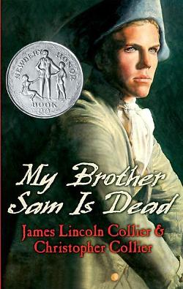 | Resource #11  My Brother Sam is Dead  (Patriot/ Loyalist)
Bibliographic Entry: | Collier, J. (2005). My brother Sam is dead. New York City, NY: Scholastic.
Dewey Decimal Notation:  F COL | Genre:  Historical Fiction | Ability Level:  Interest Level: 5-8  Reading Level: 4.9
How this resource supports the topic: | This book is about the Meeker family who is split during the Revolution. Told from the perspective of Tim, Tim’s younger brother, Sam joins the Patriots, while the rest of the family tries to stay neutral in a Tory town. This resource will help students to see how families were split based on the sides they took in the war, and how tragedy struck families when a family member died. Since this text is fictionalized, it would not be used for research, but instead as self-selected independent reading. This supplemental resource could be collected and displayed in a central location in the classroom with other texts related to the American Revolution unit. Teachers could integrate the American Revolution theme into reading and use this text for small groups, or read this book aloud.

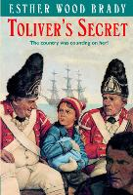 | Resource #12  Toliver’s Secret  (Patriot/Loyalist)
Bibliographic Entry: | Brady, E. (1993). Toliver’s secret. New York City, NY: Random House.
Dewey Decimal Notation:  F BRA | Genre:  Historical Fiction | Ability Level:  Interest Level: 3-6  Reading Level: 5.5
How this resource supports the topic: | This book is about a ten-year-old girl, whom disguises herself as a boy, crosses enemy lines to deliver a loaf of bread containing a message for the Patriots during the Revolutionary War. This resource will help students to see how some colonists had to act as spies during the American Revolution. This resource will also help students to see how women had to be disguised as men in the war in order to participate. Since this text is fictionalized, it would not be used for research, but instead as self-selected independent reading. This supplemental resource could be collected and displayed in a central location in the classroom with other texts related to the American Revolution unit. Teachers could integrate the American Revolution theme into reading and use this text for small groups.

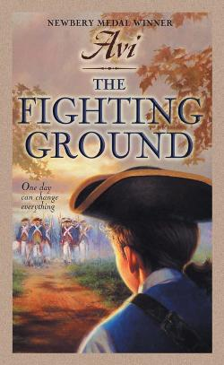 | Resource #13  Fighting Ground  (Patriot)
Bibliographic Entry: | Avi. (1987). The fighting ground. New York City, NY: HarperTrophy.
Dewey Decimal Notation:  F OSB | Genre:  Historical Fiction | Ability Level:  Interest Level: 5-8  Reading Level: 4.4
How this resource supports the topic: | This book is about thirteen-year-old Jonathan who goes off to fight in the Revolutionary War and is changed during the fight. This resource will help students to understand the experiences that soldiers went through and how they were changed. Since this text is fictionalized, it would not be used for research, but instead as self-selected independent reading. This supplemental resource could be collected and displayed in a central location in the classroom with other texts related to the American Revolution unit. Teachers could integrate the American Revolution theme into reading and use this text for small groups.

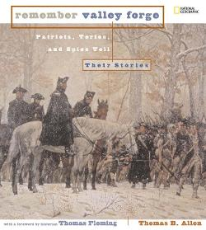 | Resource #14  Remember Valley Forge : Patriots, Tories, and Redcoats Tell Their Stories  (Patriot/Loyalist)
Bibliographic Entry: | Allen, T. (2007). Remember Valley Forge: Patriots, Tories, and redcoats tell their stories. Margate, FL: National Geographic.
Dewey Decimal Notation:  973.3 ALE | Genre:  Nonfiction | Ability Level:  Interest Level: 5-8  Reading Level: 7.9
How this resource supports the topic: | This book is about the stories from multiple perspectives (teenage solder, doctor, farmer, and spy) at the Battle of Valley Forge told through letters, journal entries, reports, photographs, and maps. This resource will help students to see the hard times, specifically disease, hunger, and cold that soldiers faced at the Battle of Valley Forge during the American Revolution. This book could be used as a resource to research different perspectives of the war or as a self-selected independent reading text. This supplemental resource could be collected and displayed in a central location in the classroom with other texts related to the American Revolution unit.

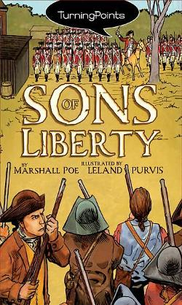 | Resource #15  Turning Points: Sons of Liberty  (Patriot/Loyalist)
Bibliographic Entry: | Poe, M. & Purvis, L. (2008). Turning points: Sons of liberty. New York City, NY: Aladdin Paperbacks.
Dewey Decimal Notation:  741.5 POE | Genre:  Nonfiction- Graphic Novel | Ability Level:  Interest Level: 3-6  Reading Level: 4.0
How this resource supports the topic: | This book is about seven years of Nathaniel’s life. Nathaniel’s father is a Loyalist who follows the rule of King George and England. However, Nathaniel witnesses many historic events, which cause him to defy his father and begin to support the Patriots during the American Revolution. This resource will help students to see the desperation, frustration and anger that people touched by war must have felt. Since this text is fictionalized, it would not be used for research, but instead as self-selected independent reading. This text would also be great for students who are reading below grade level or are reluctant readers. This supplemental resource could be collected and displayed in a central location in the classroom with other texts related to the American Revolution unit.

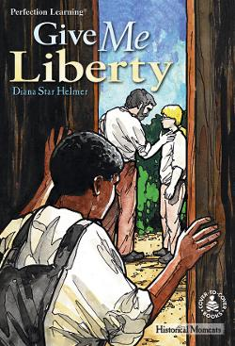 | Resource #16  Give Me Liberty  (Patriot)
Bibliographic Entry: | Helmer, D. & Hatala, D. (2000). Give me liberty. Logan, IA: Perfection Learning.
Dewey Decimal Notation:  F HEL | Genre:  Historical Fiction | Ability Level:  Interest Level: 3-6  Reading Level: 2.5
How this resource supports the topic: | This book is about Moses, an African American young slave, and his friendship with Will, a free white boy. Moses is sent off to war, since every family has an obligation to provide a solder to the Sons of Liberty, and Will must convince Moses that liberty and freedom is worth fighting for. This resource will help students to see a slave’s perspective and some of the obligations that families had, such as sending a son into battle. Since this text is fictionalized, it would not be used for research, but instead as self-selected independent reading. This text would also be great for students who are reading below grade level or are reluctant readers. This supplemental resource could be collected and displayed in a central location in the classroom with other texts related to the American Revolution unit. Teachers could integrate the American Revolution theme into reading and use this text for small groups.

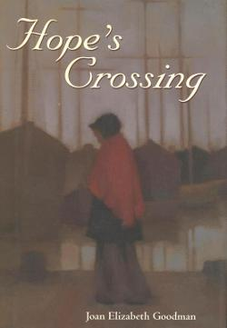 | Resource #17  Hope’s Crossing  (Patriot/Loyalist)
Bibliographic Entry: | Goodman, J. (1998). Hope’s crossing. Boston, MA: Houghton Mifflin.
Dewey Decimal Notation:  F GOO | Genre:  Historical Fiction | Ability Level:  Interest Level: 5-8  Reading Level: 5.0
How this resource supports the topic: | This book is about thirteen-year-old Hope who is kidnapped by British Loyalists during the Revolutionary War. Hope becomes friends with the grandmother in the house that she works as a servant in. Together the grandmother and Hope try to travel back to Hope’s family. This resource will help students to see the dangers of war, the separation of families, and the different perspectives of the revolution. Since this text is fictionalized, it would not be used for research, but instead as self-selected independent reading. This supplemental resource could be collected and displayed in a central location in the classroom with other texts related to the American Revolution unit.

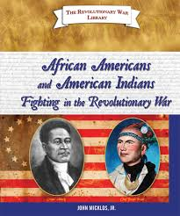 | Resource #18  African Americans and American Indians Fighting in the Revolutionary War  (Patriot/Loyalist)
Bibliographic Entry: | Micklos, J. (2009). African Americans and American Indians fighting in the Revolutionary War. Berkeley Heights, NJ: Enslow Publishers.
Dewey Decimal Notation:  973.3 MIC | Genre:  Nonfiction | Ability Level:  Interest Level: 3-6  Reading Level: 3.5
How this resource supports the topic: | This book is about the sides that African Americans and American Indians fought on during the American Revolution. This resource will help students to see the diversity of the different sides of the War. This text could be used for research or as a self-selected independent text. This supplemental resource could be collected and displayed in a central location in the classroom with other texts related to the American Revolution unit.

